Association of Boys' Schools of New Zealand

ACHIEVEMENT IN BOYS’ SCHOOLS

2017 - 2021

Nathaniel Williamson

Version 1

31 March 2023

A comparison of male achievement between coeducational and single-sex secondary schools in New Zealand from 2017 – 2021.

# Contents

Contents 1

Introduction 2

Definitions 2

Summary 3

Binary Comparison 4

Comparison of Achievement Rates 5

Spread in Achievement 5

Disaggregated by Year 6

Trend Over Time 7

Trend in Differences 8

Disaggregated by Decile 9

Trend Across Decile 10

Comparisons by Decile 11

Disaggregated by Ethnicity 12

Comparisons Between Ethnicities 13

Comparisons Between Differences 14

Conclusion 15

Summary 15

Conclusions 15

# Introduction

The ‘single-sex advantage’ refers to the historically observed phenomenon that students at single-sex institutions tend to perform better than students at coeducational institutions. It is important to validate the existence of this pattern to aid in decision-making regarding the justification of single-sex schools in New Zealand. Also essential to this aim is determining whether this relationship is causal or merely correlated due to confounding factors. We will hone in on male students for this analysis.

This report compares the attainment of NCEA and University Entrance between single-sex and coeducational schools in New Zealand for male school leavers to determine whether there is evidence that boys perform better in single-sex schools than in coeducational schools. Boys’ attainment will be disaggregated across various indicators, including year, decile, and ethnicity, to determine whether the general pattern observed holds across different time periods and demographic groups. Each disaggregation will be assigned one section containing a table of data, graph, and discussion.

The data for this report was collected from Education Counts[1] on January 27th, 2023. The cleaned dataset contains all 41 091 male students from single-sex schools and 114 539 male students from coeducational schools in New Zealand that left secondary education between 2017 - 2021.

This report is the third in a set of reports comparing boys’ attainment between single-sex and coeducational schools, spanning from 2010 to 2021. Note that each data point is an individual student in this report. In contrast, earlier reports aggregated student data into schools before performing analysis (i.e., raw student data was inversely weighted by the number of male school leavers from their school). This is necessary as school data is no longer available at Education Counts. This also means the section ordering and graph format differ from previous reports; however, all reasonable steps to maintain comparability have been made.

This report was commissioned by the Association of Boys' Schools of New Zealand (ABSNZ). Previous reports can be found at absnz.com[2].

## Definitions

Attainment rate The percentage of students in a school to attain the referenced qualification. May also be referred to as the ‘pass rate’ or ‘achievement rate’.

Ethnicity A person’s self-described cultural affiliation. Note that school leavers can select multiple ethnicities, and each ethnicity is recorded as a unique ‘person’ in a separate dataset (containing 47 254 data points affiliated with males from single-sex schools and 131 146 data points affiliated with males from coeducational schools).

Gender A person’s self-described identity, traditionally related to sex. For the analyses in this report, the group ‘boys’ includes male students who attended girls’ schools and excludes female students who attended boys’ schools, nonbinary students, and students who opted not to say.

Non-attainment rate The percentage of students in a school to leave school with no qualifications. May also be referred to as the ‘non-achievement rate’.

Qualifications This report will consider the following four secondary qualifications of increasing distinction in the NZQF[3]: NCEA Level 1 ‘level 1’, NCEA Level 2 ‘level 2’, NCEA Level 3 ‘level 3’, and University Entrance ‘UE’. Equivalent qualifications in other systems (e.g. Cambridge) are included at the relevant level in the data.

Decile A national rating of the socioeconomic conditions a school’s students come from on average, divided into ten categories – 1 (lowest) to 10 (highest). Note that this metric pertains to the region, not the school.

School type The listing of a school as either coeducational or single-sex.

School leaver A student who permanently left secondary school to enter the workforce or undertake further education between the first day of March that year and the last day of February the following year.

Single-sex advantage The historically observed phenomenon that students at single-sex institutions tend to perform better than students at coeducational institutions.

## Summary

Male school leavers from single-sex schools had higher attainment rates than those from coeducational schools at all levels across every disaggregation considered in this report. The existence of the single-sex advantage in NZ secondary schools is irrefutable. However, there is uncertainty about whether this relationship is causal or purely correlated as the analysis presented here cannot determine causality. Both positions are equally tenable until more rigorous analysis is undertaken.

# Binary Comparison

We first perform a binary comparison between male student attainment at coeducational schools and single-sex schools. This provides the most direct comparison between coeducational and single-sex schools and serves as a baseline for disaggregated comparisons later in the report.

Table 1. Percentage of male NZ secondary school leavers attaining each level of qualification, disaggregated by school type (n = 155 630).

|  |  |  |
| --- | --- | --- |
| **Highest Qualification** | **Percentage of Students** | |
| **Co-Ed** | **Single-Sex** |
| No Qualification | 14.3% | 6.3% |
| NCEA Level 1 | 10.6% | 7.0% |
| NCEA Level 2 | 28.9% | 24.5% |
| NCEA Level 3 | 16.3% | 13.5% |
| University Entrance | 29.9% | 48.7% |

All data in this report will be presented in table form to allow precise numerical comparisons and as a stacked bar chart to identify general patterns.

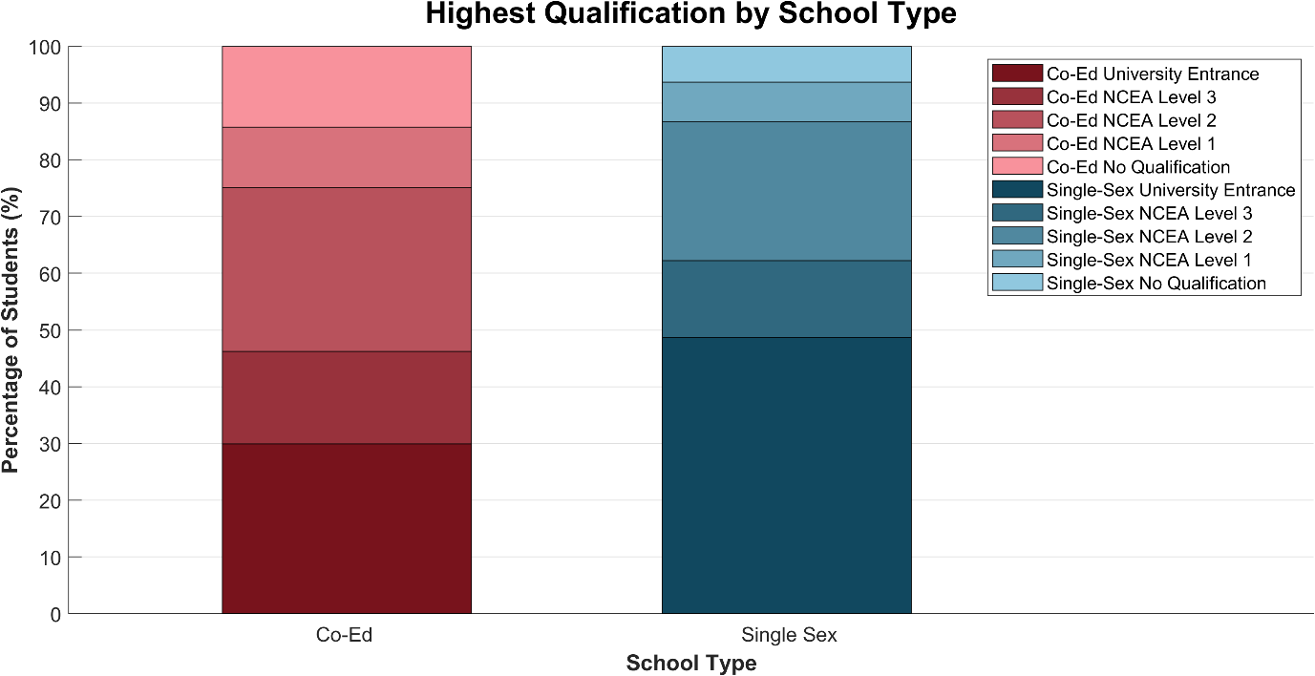

Figure 1. Generated from Table 1. Percentage of male NZ secondary school leavers attaining each level of qualification, disaggregated by school type (n = 155 630).

## Comparison of Achievement Rates

From Table 1, the male attainment rate was between 8.0 and 18.8 percentage points higher across all achievement levels for single-sex schools than for coeducational schools from 2017 to 2021. This is most prominent at the higher levels, with the UE rate almost 20 percentage points higher for single-sex schools than coeducational schools.

* The UE attainment rate is 18.8 percentage points higher for single-sex schools.
* The level 3 pass rate is 16.2 percentage points higher for single-sex schools.
* The level 2 pass rate is 11.6 percentage points higher for single-sex schools.
* The level 1 pass rate is 8.0 percentage points higher for single-sex schools.

This is strong evidence that males tend to perform better in single-sex schools than in coeducational schools. Because the number of students sampled is so large (n = 155 630), we can assert that this difference is statistically significant in correlation. However, it is essential to note that, while *correlated*, the nature of this type of analysis is not statistically sufficient to claim *causality* between school type and academic outcome. The reasons behind this correlation are likely to be complex.

## Spread in Achievement

It can be observed from Figure 1 that UE attainment is the widest band for both coeducational and single-sex schools, with lower qualification bands tending to be narrower. This effect is more exaggerated for male single-sex leavers as the higher percentage of UE achievers forces the percentages of leavers with no qualification or only level 1 to be much smaller than that of coeducational schools. This is a consequence of higher male achievement rates at single-sex schools compared to coeducational schools from 2017 - 2021.

Also worthy of note are the broad level 2 attainment bands for both coeducational and single-sex schools. They suggest an anomalously high number of students from both types of school do not pursue the NCEA pathway to level 3 or UE, instead leaving after year 12. One possible explanation of this phenomenon is that a significant number of students take up the opportunity to legally leave school upon turning 16, but decide to complete their year of study first (typically NCEA level 2 in year 12). An understanding of these students’ reasons for leaving school after year 12 (e.g., potentially to pursue trades) is required before a judgement can be made on whether this is an issue.

# Disaggregated by Year

Table 2. Percentage of male NZ secondary school leavers attaining each level of qualification, disaggregated by school type and year of leaving (n = 155 630).

|  |  |  |  |
| --- | --- | --- | --- |
| **Year** | **Highest Qualification** | **Percentage of Students** | |
| **Co-Ed** | **Single-Sex** |
| 2017 | No Qualification | 12.8% | 5.3% |
| NCEA Level 1 | 11.2% | 6.5% |
| NCEA Level 2 | 31.9% | 26.0% |
| NCEA Level 3 | 14.9% | 13.3% |
| University Entrance | 29.1% | 48.9% |
| 2018 | No Qualification | 13.8% | 5.8% |
| NCEA Level 1 | 11.4% | 7.4% |
| NCEA Level 2 | 30.6% | 25.2% |
| NCEA Level 3 | 15.2% | 13.2% |
| University Entrance | 29.1% | 48.4% |
| 2019 | No Qualification | 15.1% | 6.6% |
| NCEA Level 1 | 10.7% | 7.4% |
| NCEA Level 2 | 29.3% | 24.3% |
| NCEA Level 3 | 16.4% | 13.4% |
| University Entrance | 28.5% | 48.3% |
| 2020 | No Qualification | 14.2% | 6.3% |
| NCEA Level 1 | 9.3% | 6.2% |
| NCEA Level 2 | 25.6% | 22.7% |
| NCEA Level 3 | 17.9% | 14.2% |
| University Entrance | 33.0% | 50.6% |
| 2021 | No Qualification | 15.5% | 7.8% |
| NCEA Level 1 | 10.3% | 7.4% |
| NCEA Level 2 | 27.2% | 24.2% |
| NCEA Level 3 | 16.9% | 13.4% |
| University Entrance | 30.0% | 47.2% |

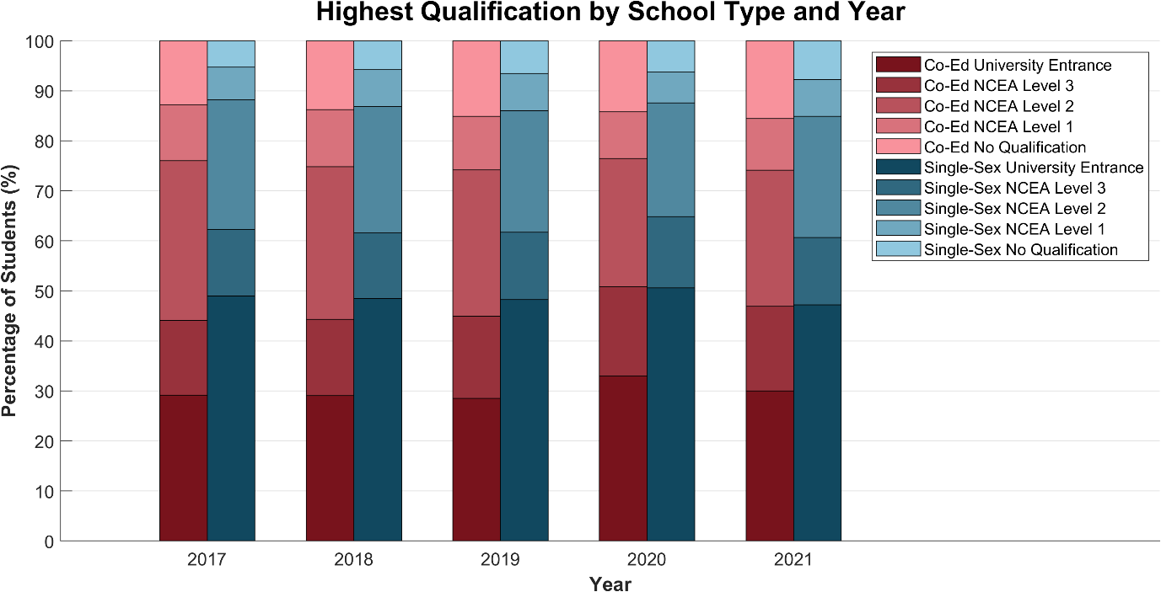

Figure 2. Generated from Table 2. Percentage of male NZ secondary school leavers attaining each level of qualification, disaggregated by school type and year of leaving (n = 155 630).

This section compares male attainment between school types from 2017 to 2021. We disaggregate over time to check that the single-sex advantage observed in the binary comparison is not an isolated event, and to investigate the long-term trend in male achievement between school types. Additionally, this analysis will reveal the effects, if any, of Covid-19 on learning and achievement in 2020 and 2021.

## Trend Over Time

Figure 2 shows that males from single-sex schools performed consistently better than males from coeducational schools at each level from 2017 – 2021, reinforcing the binary observation. A higher proportion of males at single-sex schools attained UE than both UE and level 3 in coeducational schools for four of the five years considered, while the non-attainment rate was less than half for single-sex schools compared to coeducational schools for all five years. This sustained difference rules out the single-sex advantage being a one-off anomaly.

Both school types experienced a slight peak in attainment in 2020. This is likely due to the effects of the Covid‑19 pandemic from 2020 to 2021, which drastically changed the delivery style of learning and would have impacted the ability of students to perform academically. The increase can be attributed to various countermeasures employed by NZQA to offset the disruption to education, including Learning Recognition credits[4], which presumably erred on the side of caution. However, it is surprising that a similar phenomenon was not observed in 2021, once students had already had a year to acclimate to online learning and Unexpected Event Grades for Auckland students were announced[5]. Covid-19 may have had a cumulative negative impact on students’ ability to achieve, especially for junior students entering high school during the online delivery period.

## Trend in Differences

Achievement rates remained relatively steady at both coeducational and single-sex schools, with the difference in achievement rates (single‑sex - coeducational) never varying by over five percentage points over these five years.

Over the period 2017 – 2021:

* The difference in UE attainment rate decreased from 19.8% to 17.2%.
* The difference in level 3 pass rate decreased from 18.2% to 13.7%.
* The difference in level 2 pass rate decreased from 12.3% to 10.7%.
* The difference in level 1 pass rate increased from 7.6% to 7.8%.

There appears to be an overall narrowing of the differences in attainment rates between males in coeducational and single-sex schools. This observation has been caused by decreasing single-sex attainment rates and increasing coeducational attainment rates on average over the five years. This is particularly pronounced for the level 3 pass rate, which narrowed by 4.5 percentage points from 18.2% to 13.7%. This difference may vanish in the future.

However, these changes are typically on the order of a couple percentage points and are not statistically significant. Comparisons with earlier reports are hindered by how previous analyses aggregated all male students into schools as statistical units (resulting in more fluctuation and causing males at larger schools to be underrepresented in the data) but present both supporting and opposing trends. For instance, the median difference in UE attainment in decile 1 – 4 schools *increased* from approximately 12% (30% - 18%) in 2013 to 25% (35% - 10%) in 2016[6], with others remaining constant.

Hence, either the 2017 – 2021 trend is a new occurrence or caused by random fluctuation. Because we cannot be sure, neither correlation nor causation can be claimed here. Also important to recognise is the influence of Covid-19, which will likely generate short-term, unpredictable fluctuations in the pattern. Future data gathered post-covid may be able to shed a little more light on this emergent pattern.

# Disaggregated by Decile

Table 3. Percentage of male NZ secondary school leavers attaining each level of qualification, disaggregated by school type and school decile (n = 155 630).

|  |  |  |  |
| --- | --- | --- | --- |
| **Decile** | **Highest Qualification** | **Percentage of Students** | |
| **Co-Ed** | **Single-sex** |
| Decile 1 - 2 | No Qualification | 24.4% | 8.7% |
| NCEA Level 1 | 12.7% | 8.7% |
| NCEA Level 2 | 27.6% | 27.4% |
| NCEA Level 3 | 24.8% | 21.3% |
| University Entrance | 10.5% | 33.9% |
| Decile 3 - 4 | No Qualification | 16.1% | 12.4% |
| NCEA Level 1 | 11.9% | 9.3% |
| NCEA Level 2 | 32.6% | 25.8% |
| NCEA Level 3 | 18.7% | 21.1% |
| University Entrance | 20.7% | 31.4% |
| Decile 5 - 6 | No Qualification | 13.7% | 10.2% |
| NCEA Level 1 | 12.6% | 10.4% |
| NCEA Level 2 | 35.1% | 32.1% |
| NCEA Level 3 | 16.1% | 15.5% |
| University Entrance | 22.5% | 31.8% |
| Decile 7 - 8 | No Qualification | 9.2% | 5.1% |
| NCEA Level 1 | 9.2% | 6.9% |
| NCEA Level 2 | 29.1% | 27.7% |
| NCEA Level 3 | 14.2% | 13.1% |
| University Entrance | 38.3% | 47.3% |
| Decile 9 - 10 | No Qualification | 5.8% | 2.5% |
| NCEA Level 1 | 6.0% | 3.3% |
| NCEA Level 2 | 21.7% | 14.0% |
| NCEA Level 3 | 12.2% | 9.0% |
| University Entrance | 54.3% | 71.2% |
| Not Applicable | No Qualification | 34.4% | 20.5% |
| NCEA Level 1 | 15.1% | 6.8% |
| NCEA Level 2 | 21.2% | 59.1% |
| NCEA Level 3 | 8.7% | 9.1% |
| University Entrance | 20.6% | 4.5% |

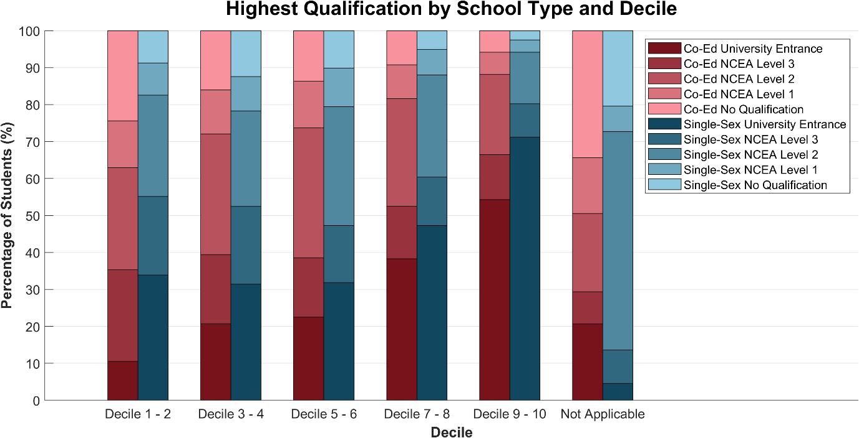

Figure 3. Generated from Table 3. Percentage of male NZ secondary school leavers attaining each level of qualification, disaggregated by school type and school decile (n = 155 630).

As previously emphasised, the nature of this investigation means the observed correlation between school type and achievement rate cannot be attributed with certainty to single-sex schools *causing* high achievement rates. It is possible, for instance, that the reputation of boys’ schools disproportionally attracts high-achieving students; alternatively, boys’ schools tend to be situated in urban areas where the population density warrants multiple schools in the same area. Other socioeconomic feedback loops may also be in play.

This section disaggregates male achievement by decile. By stratifying the data into socioeconomic categories, we aim to separate the effects of socioeconomic conditions and school type on achievement rates. This will allow us to analyse both independently of the confounding effects of the other.

We merged decile groups into pairs to improve graph readability and to preserve comparability with previous reports, which followed the same format. School leavers to whom the decile system does not apply (co-ed: n = 6188, single-sex: n = 44) are not considered for this analysis but are retained in Table 3 and Figure 3 for transparency.

## Trend Across Decile

As expected, increasing decile is correlated with increasing achievement rates and decreasing non-attainment rates across the board for both coeducational and single-sex schools (Figure 3).

UE rates increase from:

* 10.5% in deciles 1 - 2 to 54.3% in deciles 9 - 10 for males in co-ed schools.
* 33.9% in deciles 1 - 2 to 71.2% in deciles 9 - 10 for males in single-sex schools.

Non-attainment decreases from:

* 24.4% in deciles 1 - 2 to 5.8% in deciles 9 - 10 for males in co-ed schools.
* 8.7% in deciles 1 - 2 to 2.5% in deciles 9 - 10 for males in single-sex schools.

Unexpectedly, there is little change in achievement rates from decile 1 to 6 for males from both coeducational and single-sex schools. Most of the increase is observed from decile 6 to 10. Counterintuitively, the association is negative from decile 1 to 6 for single-sex schools at most achievement levels. It is unclear why this piecewise behaviour is observed, although government funding allocation to ensure all schools maintain a minimum pass rate is a possible explanation. Previous reports pointed to low numbers of low-decile boys’ schools in New Zealand as a source of variance. Although there are very few low decile single-sex data points in the dataset, the number of school leavers is much higher (n = 1853 male leavers from decile 1 - 2 single-sex schools), so this is not a plausible explanation for the trend in this report.

## Comparisons by Decile

Figure 3 also shows that male school leavers from single-sex schools perform better on average than their counterparts in coeducational schools, in each decile range and at all achievement levels.

* In deciles 1 - 2, the UE rate is 23.4 percentage points higher for single-sex schools.
* In deciles 3 - 4, the UE rate is 10.6 percentage points higher for single-sex schools.
* In deciles 5 - 6, the UE rate is 9.4 percentage points higher for single-sex schools.
* In deciles 7 - 8, the UE rate is 9.0 percentage points higher for single-sex schools.
* In deciles 9 - 10, the UE rate is 16.9 percentage points higher for single-sex schools.
* The UE rate is 18.8 percentage points higher for single-sex schools without stratification (Table 1).

With socioeconomic stratification, the differences in attainment rates between coeducational and single-sex male leavers are narrower than in the binary comparison (excluding deciles 1 - 2). There were likely socioeconomic confounding effects in Figure 1 which have now been filtered out. These disaggregated statistics are likely to be a more accurate indicator of the single-sex advantage generated by the school type specifically.

A significant gap between coeducational and single attainment rates remains after the stratification (Figure 3). Because alternative socioeconomic explanations cannot explain this remaining difference, it becomes more plausible that the difference is caused by something inherent in the school type. Causality still cannot be claimed from the analyses presented here since non-socioeconomic biases may still be present, and more rigorous research should be conducted before deeming this conclusive.

# Disaggregated by Ethnicity

Table 4. Percentage of male NZ secondary school leavers attaining each level of qualification, disaggregated by school type and student ethnicity (n = 178 400).

|  |  |  |  |
| --- | --- | --- | --- |
| **Ethnicity** | **Highest Qualification** | **Percentage of Students** | |
| **Co-Ed** | **Single-sex** |
| Asian | No Qualification | 5.7% | 2.8% |
| NCEA Level 1 | 4.7% | 3.2% |
| NCEA Level 2 | 17.6% | 10.5% |
| NCEA Level 3 | 14.8% | 8.2% |
| University Entrance | 57.2% | 75.2% |
| European/ Pākehā | No Qualification | 11.4% | 5.1% |
| NCEA Level 1 | 10.5% | 6.7% |
| NCEA Level 2 | 30.8% | 25.2% |
| NCEA Level 3 | 14.4% | 11.9% |
| University Entrance | 32.8% | 51.1% |
| MELAA | No Qualification | 11.6% | 9.7% |
| NCEA Level 1 | 7.6% | 4.2% |
| NCEA Level 2 | 26.9% | 20.6% |
| NCEA Level 3 | 17.3% | 13.8% |
| University Entrance | 36.7% | 51.6% |
| Māori | No Qualification | 25.0% | 12.8% |
| NCEA Level 1 | 14.5% | 11.1% |
| NCEA Level 2 | 31.4% | 30.8% |
| NCEA Level 3 | 17.2% | 17.9% |
| University Entrance | 11.8% | 27.4% |
| Pacific | No Qualification | 18.6% | 8.0% |
| NCEA Level 1 | 11.7% | 8.2% |
| NCEA Level 2 | 29.1% | 29.0% |
| NCEA Level 3 | 26.4% | 23.5% |
| University Entrance | 14.2% | 31.3% |
| Other | No Qualification | 13.0% | 5.6% |
| NCEA Level 1 | 10.8% | 6.2% |
| NCEA Level 2 | 27.1% | 22.6% |
| NCEA Level 3 | 15.7% | 10.2% |
| University Entrance | 33.5% | 55.4% |

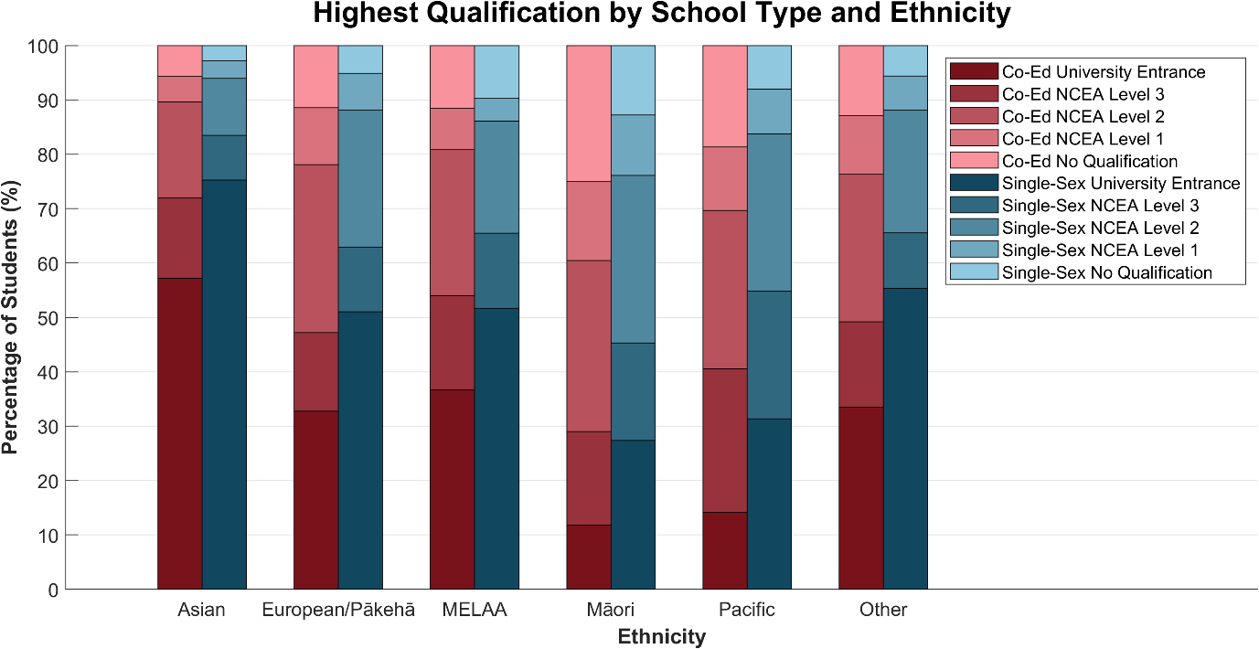

Figure 4. Generated from Table 4. Percentage of male NZ secondary school leavers attaining each level of qualification, disaggregated by school type and student ethnicity (n = 178 400).

This section compares male achievement rates across school types and ethnicities. By disaggregating achievement rates by ethnicity, we’re able to quantify the difference in achievement rates between coeducational and single-sex schools for each ethnicity. We can then identify variations in this difference between ethnicities. If it is determined that this variation is due to systematic biases hindering certain students’ ability to achieve, this data can be used to target the systematic issue.

Note that school leavers were permitted to select multiple ethnicities, each recorded as a separate instance in the dataset. These students were counted once in each ethnic group they identified with, increasing n, the total number of data points, in Table 4 and Figure 4.

## Comparisons Between Ethnicities

Figure 4 reveals differences in male achievement rates between ethnic groups from 2017 – 2021.

The lowest UE rates were found in Māori and Pacific students.

* Approximately 15% for coeducational schools.
* Approximately 30% for single-sex schools.

Moderate UE rates were found in European/Pākehā, MELAA, and other-nationality students.

* Approximately 35% for coeducational schools.
* Approximately 55% for single-sex schools.

The highest UE rates were found in Asian students.

* Approximately 60% for coeducational schools.
* Approximately 75% for single-sex schools.

These differences are statistically significant and should be considered in decision-making. It is highly unlikely that systemic/historical effects are not at least partially responsible for the large differences in achievement rates between different ethnic groups.

Across all ethnic categories, single-sex schools had a higher UE rate than coeducational schools.

## Comparisons Between Differences

The difference in UE attainment rates between coeducational and single-sex male leavers appears to be additive, while the difference in non-attainment rates appears to be multiplicative.

Table 5. Differences in UE and non-attainment rates between school types (single-sex - coeducational), disaggregated by ethnicity.

|  |  |  |
| --- | --- | --- |
| **Ethnicity** | **Difference (Single-Sex - Co-Ed)** | |
| **UE** | **Non-Attainment** |
| Asian | 18.0% | -2.9% |
| European/Pākehā | 18.3% | -6.3% |
| MELAA | 15.0% | -1.8% |
| Māori | 15.6% | -12.2% |
| Pacific | 17.2% | -10.6% |
| Other | 21.9% | -7.3% |

Notice from Table 5 that the *differences* in UE rate are relatively constant at 15% – 20%, independent of the absolute rate for either single-sex or coeducational schools. This is additive behaviour and suggests the single-sex advantage is proportionally stronger for ethnic groups with lower attainment rates.

In comparison, non-attainment differences fluctuate significantly more and are approximately proportionate to the absolute non-attainment rate in each category. This multiplicative behaviour leads to a stronger single-sex advantage effect for ethnic groups with higher non-attainment rates.

The combination of these factors means that disadvantaged demographics appear to benefit the most from single-sex education in the dataset. From earlier, achievement metrics favour single-sex education across all ethnic groups. Speculating, it is possible that increasing enrolment at single-sex schools could help bridge the ethnic gap while still promoting excellence across all ethnic groups, at least for males. A similar opportunity may exist for other genders. Crucial to reiterate is that these causal conclusions cannot be evidenced by the analysis presented here.

# Conclusion

This report compared male school leaver achievement rates between single-sex and coeducational schools in New Zealand between 2017 and 2021 to find evidence for the single-sex advantage.

## Summary

In an exploratory binary comparison, we found that school leavers had higher achievement rates at single-sex schools than at coeducational schools at all qualification levels.

Upon disaggregating by year, we consistently observed this pattern across the five years, lending credence to a sustained difference between single-sex and coeducational achievement rates. We found inconclusive evidence that this difference was narrowing over time.

Upon disaggregating by decile, we found that school leavers had higher achievement rates at single-sex schools at each decile level. By stratifying the data into deciles, we filtered out some potential socioeconomic confounding effects. The remaining data still exhibited the single-sex advantage, albeit to a lesser extent, so we could be reasonably confident that socioeconomic influences account for some but not all the difference. Other confounding effects may remain.

Upon disaggregating by ethnicity, we found that school leavers had higher rates of achievement at single-sex schools in each ethnic group. Additionally, we found inconclusive evidence that suggested the single-sex advantage affected disadvantaged demographics the most. It was tentatively posited that this could be leveraged to narrow the ethnic gap in academic attainment with a positive impact on all ethnic groups.

These results are largely in agreement with previous reports.

## Conclusions

From the results obtained, we can claim that school leavers did have higher achievement rates at single-sex schools than at coeducational schools *from 2017 – 2021*. Additionally, because the number of students sampled is so large (n = 155 630), we can assert that this difference is statistically significant. This allows us to extend our claim to the near future, as long as we assume the trend observed continues beyond 2021. We observed an extremely consistent trend in the year disaggregation, even despite Covid-19, so this assumption seems reasonable.

Hence, it can be claimed that NCEA and UE achievement rates are higher for male school leavers from single-sex schools than male school leavers from coeducational schools in New Zealand secondary schools.

Note the emphasis on existence over causation. Because we couldn’t eliminate all sources of bias and confounding effects due to the nature of using public, observational data, we cannot be sure that single-sex education is the *cause* of increased achievement rates. For example, a reputation for excellence may cause aspirational students to tend towards single-sex schools – this data cannot tell. Equally, we are unable to confirm the opposite causal claim. The true direction of causation is likely to be a combination of both. A more rigorous investigation is required to quantify the proportion of causation due to the nature of boys’ schools.

1. https://www.educationcounts.govt.nz/statistics/school-leavers
2. http://www.absnz.co.nz/research.html
3. https://www.nzqa.govt.nz/qualifications-standards/understanding-nzqf/
4. https://www.nzqa.govt.nz/ncea/understanding-ncea/changes-to-ncea-and-ue-for-2020/
5. https://www.nzqa.govt.nz/ncea/understanding-ncea/changes-to-ncea-and-ue-for-2021/
6. http://www.absnz.co.nz/achievement-2013-16.html